Exercise 17

1. Find and list the ids and spouse names of all employees who are married.

SELECT e_id, s_name FROM employee_per WHERE m_status = 'M';

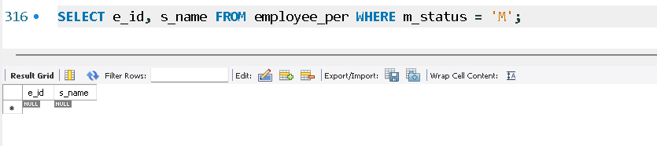

2. Change the above so that the display is sorted on spouse names.

SELECT e_id, s_name FROM employee_per WHERE m_status = 'M' ORDER BY s_name;

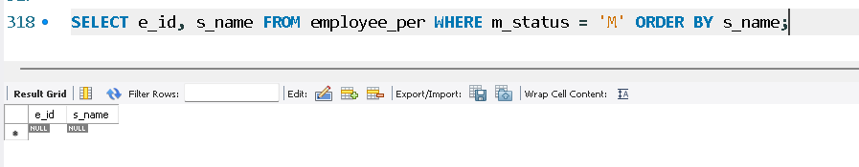

3. How many employees are there?

SELECT COUNT(*) FROM employee_per;

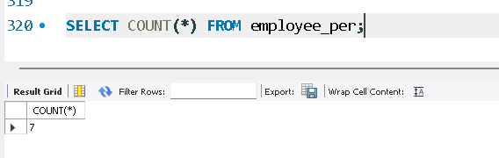

4. How many of your employees are married and unmarried (female)?

SELECT m_status, COUNT(*) FROM employee_per WHERE sex = 'F' GROUP BY m_status;

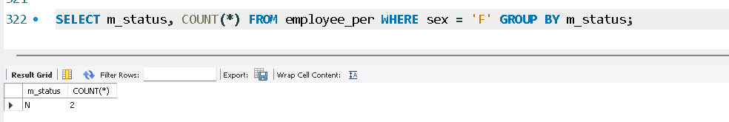

5. Make unique groups of children and find the number in each group.

SELECT children, COUNT(*) FROM employee_per GROUP BY children;

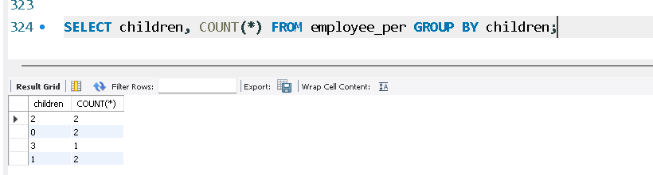

6. Sort the display with the group having maximum children at the top.

SELECT children, COUNT(*) AS num_employees

FROM employee_per

GROUP BY children

ORDER BY num_employees DESC;

